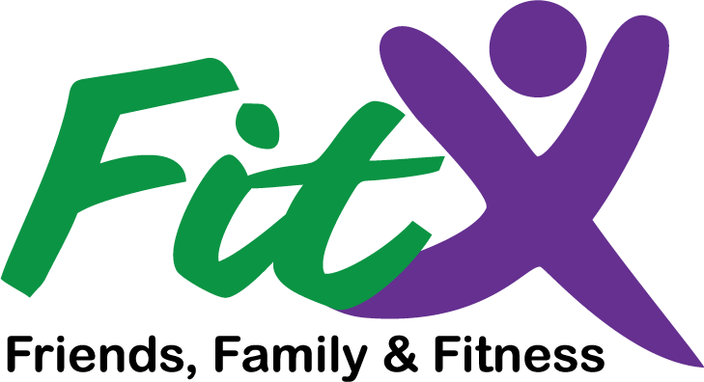 | An eight-week team-based  physical activity program
Get fit together!
Statistics show group exercise increases motivation

Form a team!
Four to six people sign up as one team; select a captain and a team name, and get walking!

Monitor your fruits & veggies!
Keep track every day at www.fit-ex.org

What are you waiting for?
Get in touch with the VCE contact below!

Contact:
AGENT INFORMATION HERE

Go Fast. Go Slow. Just Go.
Your local coordinator:
CONTACT INFO AND PICTURE HERE
Team captain registers with local coordinator
Select a team captain, team name, and team goals
3
2
1
Form a team of 6 to ‘walk across Virginia’
How do I get started?
Sign Up Today!
Coming to XXXXX County
April 2 to May 27, 2017
More at:
www.Fit-Ex.org
Fit Ex is an exciting program from Virginia Cooperative Extension. It will help you get motivated and get moving. FIT Extension can also help you improve your diet and overall quality of life.
8- week team-based program
Only $2 per person!
a team-based program that will improve your life!  Exercise changes everything  Brought to by… | 8 weeks:  April 2  -  May 27  - Form a team of six to “walk across Virginia”  - Select a team captain, name,  and goals  - Team captain registers with coordinator  (below)  contact:  AGENT NAME  AGENT TITLE  AGENT PHONE  AGENT EMAIL  www.fit-ex.org

teams go the distance

Don’t like to exercise alone? Try FitEx!
For eight weeks, teams enter into friendly competition to achieve fitness goals!

Four to six people create a team, set fitness goals, and register with a local VCE coordinator.
Sign up today to begin your fitness journey. It really is that simple!

Local coordinator
CONTACT INFORMATION HERE

